NDIS First Nations Strategy 2025–30

Acknowledgement of Country
The NDIA acknowledges the Aboriginal and Torres Strait Islander peoples of this nation and the Traditional Custodians of the lands across which our Agency conducts our business. We pay our respects to the custodians of the land on which we work as well as their ancestors and Elders, past and present.
The NDIA is committed to honouring Aboriginal and Torres Strait Islander peoples’ unique cultural and spiritual relationships to the land, waters, seas and their rich contribution to society.
The term First Nations people is respectfully used throughout the document to be inclusive of the diverse Aboriginal peoples and Torres Strait Islander nations across Australia and their unique ‘Country’, Kinship and Ways of Knowing, Being and Doing.

The artwork

Figure 1: Artwork ‘Belonging’ by Charmaine Mumbulla

About the artist
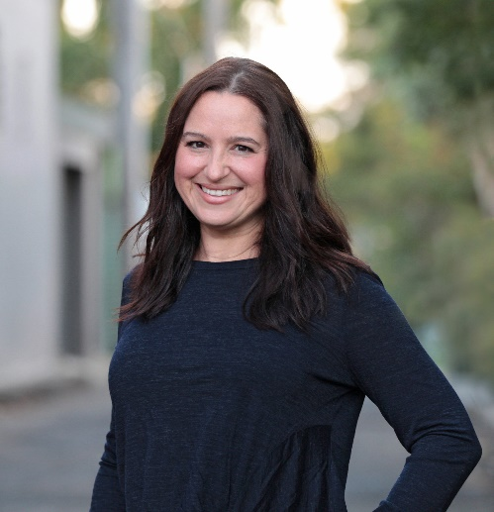
Charmaine Mumbulla is a Kaurna and Narungga woman from the Yorke Peninsula, with family ties to the Gumbaynggirr people of the NSW Mid-North Coast. Together with her partner she runs an Aboriginal creative agency called Mumbulla Creative. Charmaine is passionate about working on projects that support social justice. She works closely with organisations to tell their stories through her art.

About the artwork ‘Belonging’
The vision of the National Disability Insurance Scheme (NDIS) is to create an inclusive Australia for people with disability. This artwork features themes of inclusivity and belonging.
Belonging is represented by the large circle at the centre of the artwork. This is significant because the core intention of the NDIS is to facilitate and enhance a sense of belonging within the community for those who require assistance.
The small u-symbols within this circle represent the diversity of people and communities coming together within the safety of the larger circle. This symbolises an inclusive Australia where everyone belongs and is able to gather together equally.
Three interconnected circles to the side represent the three core functions of the NDIS. These include individually tailored supports for eligible people with a disability, information and referrals for all people with a disability and their carers and to create community awareness of the issues that affect people with disability and encourage community capacity building.
The weaving parallel lines that run throughout the artwork signify the journey that people with a disability embark on by engaging with the core functions of the NDIS. As such, it represents the connections between individuals and services within the community.
A stylised shooting star at the top symbolises the NDIS vision for an inclusive Australia for people with disability.
The expansive and diverse countries where the NDIS deliver its services across Australia are represented in the artwork and include the red dust desert, temperate rainforest, saltwater coastal countries and inland freshwater regions.

Symbolism in artwork

Strategic Priority Area 1: Fair and equitable access and support

This artwork element represents ‘Fair and equitable access and support’. It depicts an organic shape at the centre with small white dots. The shape is surrounded by u-symbols. The shape indicates the importance of place-based approaches in the provision of services. The u-symbols represent people working together to improve access and participation in the NDIS for First Nations people.

Strategic Priority Area 2: NDIS ‘our way’ – transformation for power-sharing

This artwork element represents ‘Transformation for power-sharing’. The two circles represent a co-design approach between Aboriginal and Torres Strait Islander communities and government. They are connected by a pathway which shows strengthening of ties. The smaller circles along the pathway represent independence of choice, cultural safety, kinship mapping and communication.

Strategic Priority Area 3: Working together well within and across sectors

This artwork element represents ‘Working together well within and across sectors’. It depicts a circular shape at the centre surrounded by u-symbols and radiating dots. The u-symbols are symbolic of cross-sector collaboration. The radiating dots show the positive benefits of working together for improved outcomes through accountability and evidence.

Strategic Priority Area 4: Gathering, sharing and revisiting knowledge about meaningful change

This artwork element represents ‘Gathering, sharing and revisiting knowledge about meaningful change’. It depicts a circular shape at the centre encased by two sets of parallel lines. The parallel lines, distinct yet unified, are symbolic of accountability and evidence, which are used to measure tangible outcomes. The shape at the centre is representative of cultural knowledge.

Acknowledgements
The National Disability Insurance Agency (NDIA) acknowledges the voices of First Nations peoples from the Disability Royal Commission, NDIS Review and Closing the Gap Review. We thank those who have shared their stories, which have informed and shaped the NDIS First Nations Strategy 2025–2030. The NDIA also gratefully acknowledges the members of the First Nations Strategy Working Group for their input and guidance on the strategy, and facilitators Justin Noel and Kathleen Stacey.
Table 1: First Nations Strategy Working Group Members, organisation and role
Name | Organisation and role
Jake Briggs | Independent Advisory Council (IAC) – Children, Young People and Families Reference Group member; founder, Culture Connex
Thom Calma | Executive Manager, Disability Supports, Participate Australia and SydWest Multicultural Services
Aaron Chambers | Executive Manager, Rumbalara Aboriginal Co-operative
Janine Coombs | Deputy Chair, Barengi Gadjin Land Council
Dr Jennifer Cullen AM | Co-Chair, IAC– Equity and Inclusion Reference Group; CEO, Synapse
Thea Dunkley | Director, Disability and VET Workforce, National Aboriginal Community Controlled Health Organisation
Dr Lynore Geia | Nursing and Midwifery Academic
Ara Harathunian | Managing Director, Kultchafi; Board member, Indigenous Wellbeing Centre (IWC)
Joel Robinson | Participant First (NDIA) member
Suzy Trindall | IAC – Equity and Inclusion Reference Group member
Andrew Vodic | Chief Executive Officer, Community Disability Alliance Hunter
Ruth Whybrow | Participant First (NDIA) member

Contents
Acknowledgement of Country 2
The artwork 3
Symbolism in artwork 5
Acknowledgements 7
Contents 8
Suzy’s lived experience of disability helps shape the strategy 10
A message from the Minister for the National Disability Insurance Scheme 11
A message from the CEO 13
A message from the DCEO 15
Lynore provides a voice for remote communities 17
1. Introduction 18
2. Our goal and commitments to ways of working 22
3. Structure of the First Nations Strategy 26
Ara seeks easier access to the NDIS 27
4. Strategic priorities 28
Strategic priority 1: Fair and equitable access and support 29
Strategic priority 2: NDIS ‘our way’ – transformation for power-sharing 34
Strategic priority 3: Working together well within and across sectors 38
Strategic priority 4: Gathering, sharing and revisiting knowledge about meaningful change 43
Ruth advocates for disability equity 48
5. Appendix 49

Suzy’s lived experience of disability helps shape the strategy
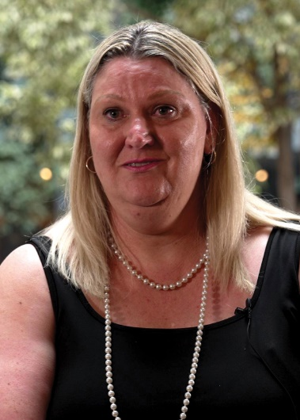
I know firsthand how much my mob need better access to culturally safe NDIS supports and services. As a proud Gadigal woman with disability, I’ve spent over a decade working with the Community Disability Alliance Hunter in Newcastle, NSW. Through my role as a peer worker and mentor, I have diverse experiences to share, along with those of my community.
It’s a privilege to help shape the NDIS First Nations Strategy. I take this responsibility seriously as I want to do right by First Nations people with disability who need a voice. Many people I work with face significant challenges in accessing the NDIS. Many also find it hard to advocate for themselves. That’s why I’m here. Even though it doesn’t come naturally, if I can make a difference, I will.
What stood out to me about this process was the people. We each brought different perspectives, and our deep sense of connection made our contributions even more meaningful. Together we’re helping to change lives for the better.
Suzy Trindall
Gadigal People of the Eora Nation

A message from the Minister for the National Disability Insurance Scheme
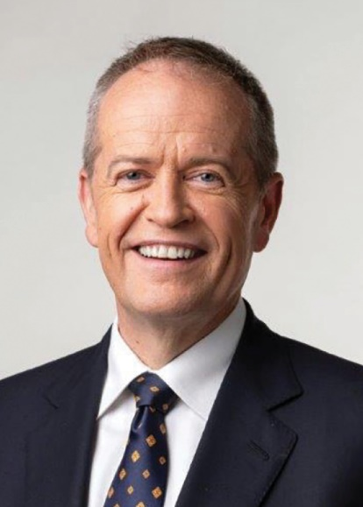
As Minister for the National Disability Insurance Scheme (NDIS), I am pleased to support the release of the inaugural NDIS First Nations Strategy.
For the first time, the strategy establishes clear priorities and a roadmap for change to ensure the NDIS creates improved outcomes for First Nations people with disability. This strategy is an important part of getting the NDIS back on track to ensure it delivers on its original vision promised to First Nations people with disability and is here for future generations of Australians. Importantly, this strategy also delivers on a key National Disability Insurance Agency (NDIA) commitment under the National Agreement on Closing the Gap.
This strategy paves the way for First Nations people with disability to call for change that is meaningful for First Nations communities and commits the NDIA to improve the NDIS through partnership, co-design and power sharing. It offers a transformational approach to strengthening the voice of First Nations peoples to determine their own futures with the support of government. The 4 key areas for reform are critical to make the NDIS more equitable, culturally safe, community-centred and coordinated for First Nations peoples.
This strategy is just one part of a longer journey to improving the NDIS for First Nations people with disability. First Nations people with disability continue to face significantly higher barriers to accessing and participating in the NDIS – we have heard clearly that First Nations people with disability continue to be uniquely marginalised through the Independent Review of the NDIS and Disability Royal Commission. There is more to do to ensure the NDIS reaches its full potential and serves the needs of all communities.
Thank you to the many First Nations people, groups and organisations who have engaged with the NDIA and the government over many years, inquiries, workshops, and meetings. The strategy is the result of years of engaging with many diverse voices of First Nations people on the priorities to improve outcomes for First Nations people with disability and their families and carers.
A particular thank you to those that advised on this strategy and shared learnings, experience and expert understanding to support its development – including representatives of First Nations NDIS participants, providers, partners, peak bodies, carers, advocates, and key departments and agencies. The feedback collated through the Disability Royal Commission, the Independent Review of the NDIS and the Productivity Commission Review of the National Agreement on Closing the Gap also informed the strategy and represent over 650 submissions by First Nations organisations and individuals.
I now look forward to the NDIA commencing work to co-design the First Nations Strategy Implementation Plan with First Nations communities. Realising the potential of the strategy will require continued collaboration and concerted efforts to make the changes called for by First Nations people with disability.
The Hon Bill Shorten MP
Minister for the National Disability Insurance Scheme
Minister for Government Services

A message from the CEO
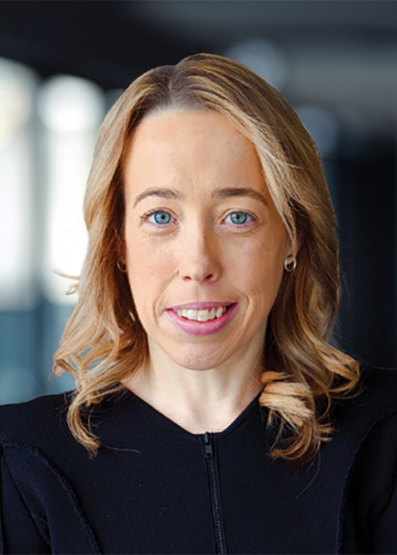
The NDIA is committed to an equitable Australia for First Nations people with disability.
I am honoured to launch the NDIS First Nations Strategy alongside Minister Shorten and Deputy Chief Executive Officer, First Nations, Dr Janine Mohamed.
The NDIS First Nations Strategy forms the centrepiece of the NDIA’s reform agenda for improving outcomes for First Nations participants, their families and carers. Importantly, it also sets out the steps we will take to implement meaningful action.
We have long heard from First Nations communities about the challenges that First Nations people experience when accessing and using the NDIS – a message that was further amplified by the Disability Royal Commission and the Independent Review of the NDIS.
I welcome the NDIS First Nations Strategy as a critical step in championing a strengths-based pathway for change. One that delivers on commitments made by the NDIA under the National Agreement on Closing the Gap.
At its core, this strategy reinforces the importance of listening in order to implement change. Indeed, it is the knowledge and experiences of people with disability that will form the basis for transforming the NDIS.
I commend the work of the NDIS First Nations Strategy Working Group and the former NDIA First Nations Advisory Council for combining elements of truth telling with a vision for the future. This work has allowed us to set priorities that are enshrined in self-determination and power-sharing.
The NDIS First Nations Strategy makes clear that NDIS policies and programs must be developed with consideration of First Nations perspectives, experiences and interests at all levels.
It calls for partnerships with First Nations communities and for collaboration across all sectors and jurisdictions to provide equitable, culturally safe and holistic community-based models of care.
The next step in our journey is to roll out the strategy. In 2025, the NDIA First Nations Group will embark on a process of community engagement and co-design.
This consultation period will support us to develop a strategy implementation plan and an evaluation framework that will help us measure progress.
It’s critical the NDIA, and our partners across government and non-government sectors, embed this strategy into our everyday work and implement it together, reflecting the positive spirit in which it was developed and written.
I look forward to taking these next steps with you as we continue to create a more equitable and culturally safe NDIS.
Rebecca Falkingham
Chief Executive Officer

A message from the DCEO
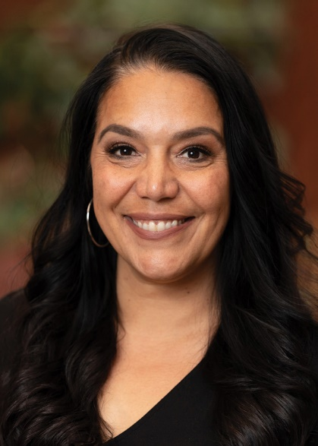
As a Narungga Kaurna woman from South Australia and the inaugural Deputy CEO First Nations, I am extremely proud of the NDIS First Nations Strategy.
First Nations people with disability have the universal right to equity, dignity and self-determination – so they can live the lives that they want and deserve to live.
This NDIS First Nations Strategy is about deeply listening and acting upon the valued voices of First Nations people with disability, their families and carers – a strategy that has the real potential to make a difference in people’s lives.
We are resolutely committed to First Nations leadership and system reform to support First Nations people with disability.
We know First Nations people face many forms of disadvantage and racism. That’s why it’s important that this strategy has cultural safety at its core. For First Nations people with disability, cultural safety is not just an option – it is essential, and it is best practice for everyone.
Cultural safety creates environments where First Nations people feel understood, respected and valued. Where their needs and aspirations are taken seriously and prioritised.
Cultural safety honours and embeds First Nations ways of knowing, being and doing into our systems, policies, services and supports. It’s about sharing power with First Nations people, honouring historical truth telling and committing to never repeating the wrongs of the past. It’s about meeting First Nations people where they are at and providing services commensurate with need.
Cultural safety will always be determined by First Nations people, but requires allyship by non-Indigenous people. Allies of First Nations people are critical to advocating for equity, promoting anti-racism, accountability, and sharing power and the workload at all levels.
This strategy is a significant step forward for the NDIA and the Australian Government. It delivers on a commitment under the National Agreement on Closing the Gap and responds to the findings of the Disability Royal Commission and the Independent Review of the NDIS.
It supports Australia’s Disability Strategy and the Closing the Gap Disability Sector Strengthening Plan. Importantly, it upholds the principles of the United Nations Convention on the Rights of Persons with Disabilities.
The real test of this strategy will be in rolling it out and remaining accountable. The next phase of work for the NDIA involves co-designing an NDIS First Nations Strategy Implementation Plan in partnership with First Nations communities.
We will do this to ensure the priorities in this strategy translate into real and measurable outcomes for First Nations people with disability and their families, communities and advocates.
I want to thank everyone who has contributed to this important work over many years. Your insights and leadership have been critical to co-creating a strategy that reflects a shared vision of cultural safety, equity and self-determination for First Nations people with disability.
Together, we are building a stronger future for transformative change.
I look forward to your continued support as we take the next steps to shape an NDIS that is safe, accessible and equitable for all.
Dr Janine Mohamed
Deputy Chief Executive Officer, First Nations Group

Lynore provides a voice for remote communities
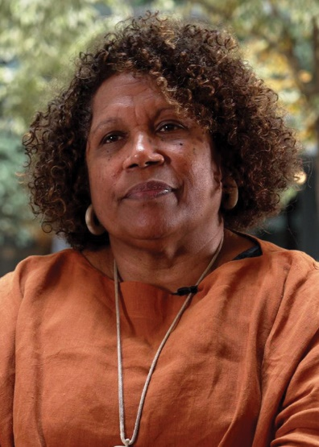
I am a Bwgcolman woman, an Aboriginal and Torres Strait Islander woman born and raised in the Aboriginal community of Palm Island, ‘Bwgcolman Country’ off the coast of North Queensland. My people have been here since 1918, spanning seven generations. We are from many tribes that were forcibly relocated to Palm Island, who now have become one people.
My interest in First Nations disability stems from my lived experience in community as well as my work as a health professional. I am a Professor of Nursing and Midwifery, I also enjoy working from my home on Palm Island because I can work with and share my health and academic experience with my community.
I am privileged to be part of the NDIS First Nations Strategy and help set the direction for change. This work is especially important for remote First Nations communities like mine. We are separated from the mainland and accessing effective services is difficult. I’m pleased that my voice has been heard and I’m able to raise awareness about what's happening on the ground.
This work is a prompt for people in power to think about how they can bridge the gap between policy makers and people living in community, and how they can provide improved services that respond to community needs.
Lynore Geia
Bwgcolman

Introduction

Purpose of the First Nations Strategy
The goal of this National Disability Insurance Scheme (NDIS) First Nations Strategy is to ensure the NDIS delivers and continues to create improved outcomes in the lives of First Nations people with disability.
The strategy will serve as a roadmap to guide the actions of the NDIA over the next 5 years, from 2025 to 2030, to improve NDIS access and participation for First Nations people with disability.
The strategy embeds the knowledge and experiences of First Nations people and reflects First Nations concepts of disability and wellbeing. This includes how priorities are expressed and how success and outcomes are measured.
The strategy identifies 4 priority areas for action:
- Strategic priority 1: Fair and equitable access and support – this focuses on the experiences of First Nations people with disability, their families, communities and advocates, as they apply for the NDIS, navigate the NDIS pathway and choose service providers and services.
- Strategic priority 2: NDIS ‘our way’ – transformation for power-sharing – this is about the decisions the NDIA takes about policy, programs and quality standards, and the way the NDIA co-designs and funds culturally safe and effective services for First Nations participants.
- Strategic priority 3: Working together well within and across sectors – this focuses on better systems within the NDIS and stronger collaboration between services and sectors at the national, regional and local levels that support a smoother NDIS journey for First Nations participants.
- Strategic priority 4: Gathering, sharing and revisiting knowledge about meaningful change – this priority is about how the NDIA is accountable for tracking change over time in the experiences of and outcomes for First Nations participants, their families, communities and advocates, and then using the learnings for ongoing improvement.
Each priority sets out clear objectives for transformational change. Together, the priorities call on the NDIA to partner with First Nations communities to co-design equitable NDIS systems and pathways. The priorities also call for culturally safe services and supports that can be accessed by First Nations people regardless of where they live.

How the strategy was developed
The strategy was co-developed by the NDIA and the NDIA First Nations Strategy Working Group, which comprised First Nations NDIS participants, carers, providers, partners, peak bodies, non-government organisations, academics and advocates. The former NDIA First Nations Advisory Council also played an important role.
Each element of the strategy was carefully deliberated in a sequential way. The intention was to ensure that the aspiration, intent and scope of the strategy would do justice to what we have heard from the Disability Royal Commission, the NDIS Review and the Productivity Commission’s review of the National Agreement on Closing the Gap.

What needs to change
The prevalence of disability is much higher in First Nations populations than in the general Australian population. First Nations people make up 3.2% of the Australian population, yet account for around 9.4% of total NDIS participants. We know that many more First Nations people who need disability services and supports are not participants of the NDIS.
First Nations people face multiple barriers to accessing and participating in the NDIS. These include the high costs of medical assessments, a lack of culturally safe and holistic disability services, and a transitional workforce.
The experiences of First Nations people with disability are interlinked with the ongoing impacts of colonisation, intergenerational trauma and systemic racism. First Nations people with disability can also experience intersecting forms of hardship relating to their identities as both a First Nations person and a person with disability. This is referred to as ‘double discrimination’.
The discrimination experienced by First Nations people with disability is compounded across sectors, including health, justice, education, employment, housing and transport services. This is reflected in the over-representation of First Nations people with disability in the criminal justice system, child protection and other institutions, and in their economic and social exclusion. These experiences are often exacerbated in remote and very remote communities.
A fundamental factor that can influence change is governments working together in partnership with First Nations people. By sharing power with First Nations people, the NDIA can co-design place-based solutions that honour First Nations communities and ensure culturally safe and holistic supports. This approach can also help to shift the deficit-based narrative to a strengths-based and self-determining one, where First Nations people have the collective agency to shape the disability services and supports that they need.
For the NDIS First Nations Strategy to succeed, all levels of government and all related sectors will need to join with First Nations communities, including Aboriginal community-controlled organisations, to implement the equitable, sustainable, culturally safe and continuously improving community-based services and supports that are required.

The policy context
The strategy aligns with the principles of the United Nations Declaration on the Rights of Indigenous Peoples (UNDRIP) and the United Nations Convention on the Rights of Persons with Disabilities (UNCRPD). The UNDRIP works alongside the UNCRPD to protect and promote the rights of Indigenous peoples to self-determination. The NDIS First Nations Strategy contains practical actions to protect and promote the rights and dignity of First Nations peoples with disability.
This strategy also articulates a First Nations voice for achieving Australia’s Disability Strategy 2021–31, which calls on all Australians to ensure that people with disability can participate as equal members of society.
The strategy further advances an NDIA commitment under the National Agreement on Closing the Gap, in which disability is a cross-cutting measure. The strategy builds on the Closing the Gap Disability Sector Strengthening Plan and its guiding principles. These establish a minimum standard of practice for the development and implementation of policies, programs, services and systems for First Nations people with disability.
The NDIA acknowledges that the rights of First Nations people with disability cannot be separated from First Nations concepts of holistic physical, cultural, social, emotional and spiritual health and wellbeing. First Nations people’s cultural understandings of disability are different to the dominant concepts of disability, especially the focus on individual impairment versus community and collective wellbeing.

Next steps
The next critical step for this strategy is to operationalise it through an NDIS First Nations Strategy Implementation Plan. This plan will describe how the strategic priorities will be achieved. It will include actions, timelines, responsibilities, measures and reporting requirements that will help to track and evaluate progress against the strategy.
The NDIA will co-design the implementation plan during 2025. We will do this in partnership with First Nations participants and the broader First Nations disability community, including families, carers, providers, partners, peak bodies and government and non-government organisations. We acknowledge that different communities have different needs. We want to embed the NDIA commitments, enshrined in this strategy, of self-determination and community-centred ways to improve the NDIS for First Nations people with disability.

Our goal and commitments to ways of working
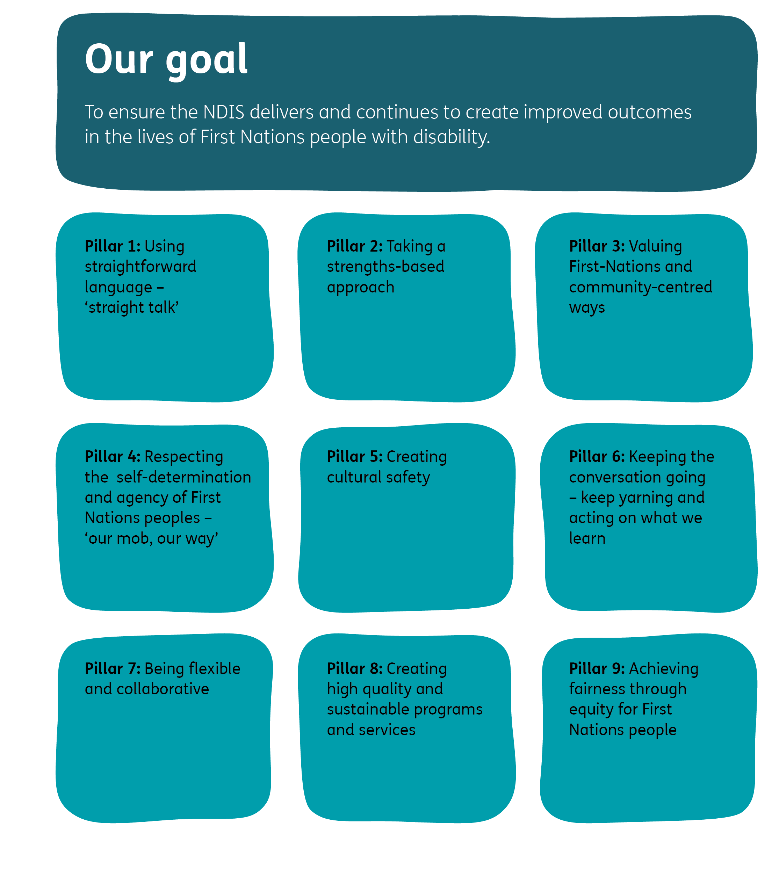

Our goal
To ensure the NDIS delivers and continues to create improved outcomes in the lives of First Nations people with disability.

Our commitments to ways of working
As an organisation, we are making 9 commitments to ways of working that reflect First Nations ways of knowing, being and doing. These commitments represent 9 equally strong and inseparable pillars as a strong foundation that upholds the spirit and intent of the NDIS First Nations Strategy. All must be honoured to achieve the goal.

Pillar 1: Using straightforward language – ‘straight talk’
Language used in the NDIS is often not familiar everyday language to many people. We will focus on using more straightforward language wherever we can. We will not assume that NDIS language is familiar to everyone, and we will make sure we clearly explain what particular words mean when it is important to use those words.

Pillar 2: Taking a strengths-based approach
The word ‘disability’ focuses on what people cannot do. There are always things that people can do. There are always strengths that people bring to a situation. There is a long history of First Nations people being described in ways that focus on deficits. We will take an approach that is based on recognising and respecting the strengths of First Nations people with disability and First Nations’ families, communities and organisations.

Pillar 3: Valuing First Nations and community-centred ways
First Nations cultures and communities hold values that are different to mainstream organisations. Holistic ways are important – this means giving equal focus to physical, cultural, social, emotional and spiritual aspects of life and how they are connected to each other. Family and community-centred ways are important. The NDIS is mainly focused on individuals. Valuing First Nations and community-centred ways will require us to shift the way we do things in the NDIS and respect First Nations’ approaches to supporting First Nations people with disability.

Pillar 4: Respecting the self-determination and agency of First Nations people – ‘our mob, our way’
Self-determination means that First Nations ‘people are entitled to control their own destiny’ and manage their own affairs. This means First Nations people with disability, together with their families, communities and advocates, have a meaningful role in leading, directing and deciding on the best ways to support First Nations people with disability. The role of the NDIA is to listen, learn and act on what is learned, and to support First Nations-led programs and services.

Pillar 5: Creating cultural safety
First Nations people with disability, their families, communities and advocates, must feel culturally safe throughout the NDIS journey. We will help and encourage our staff, partners in the community and all NDIS service providers to learn what cultural safety means, why it is central to good practice and how to create it. We do not want First Nations people to experience situations where no consideration is given to cultural needs or protocols, or for racism to occur during their NDIS journey. We want First Nations people to feel welcomed, respected, believed, validated and valued.

Pillar 6: Keeping the conversation going – keep yarning and acting on what we learn
An important part of creating cultural safety is continuing to learn what this means to First Nations people involved with the NDIS. It is important to keep yarning. It is equally important to learn, and then act on what we learn, so we keep all our commitments and are accountable for our decisions and actions.

Pillar 7: Being flexible and collaborative
We must be flexible and collaborative to keep all our commitments. We will learn new things, so we will need to adapt and change the way we work with First Nations people with disability, their families, communities and advocates. We need to do this together with First Nations people and follow their leadership on what works best for First Nations people with disability.

Pillar 8: Creating high quality and sustainable programs and services
First Nations people with disability have a right to high quality support that is culturally safe. It is important we do everything we can to ensure that NDIS services provide high quality support and are consistently available. In this way, First Nations people with disability, wherever they live, can build trust in and know they can rely on NDIS supports and services.

Pillar 9: Achieving fairness through equity for First Nations people
First Nations people with disability have a right to fair access and support so they can achieve outcomes that are equal to non-First Nations people with disability. We will not achieve this by doing things in the same way – we must do things differently to create equity.

Structure of the First Nations Strategy
Each strategic priority has 5 parts that cover what needs to change, why it is important and how we will know the change we want is happening.

We know this is happening if
This is an outcome statement that describes what will be happening consistently by the end of the First Nations Strategy timeframe for each strategic priority.

Focus areas
Each priority has 3 or 4 focus areas. The work done for each area will, in combination, help achieve the outcome statement. How this work is done will be detailed in the implementation plan.

Objectives
The objective for each focus area describes what the NDIA intends to change.

What does success look like
This describes what will be different if the change described in the objective is achieved.

Ara seeks easier access to the NDIS
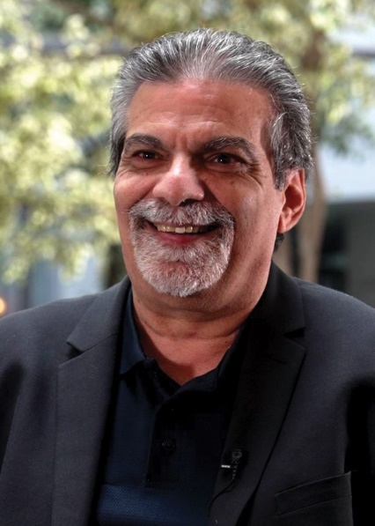
I am a respected member and Elder of an Aboriginal, South Sea Islander and Torres Strait Islander family, with connections with the Kabi Kabi, Teribelang Bunda and Gooreng Gooreng of Queensland. I have 40 years of experience in delivering Indigenous cultural services Australia-wide. Through my work, my aim is to bring reconciliation, communication and understanding between Indigenous and non-Indigenous people.
I feel honoured to be part of the NDIS First Nations Strategy Working Group – to collaborate, to listen and be heard.
I’m a passionate advocate for improved access to the NDIS for First Nations peoples. I have family members with disability and I work with First Nations people with disability. I know that barriers to the NDIS exist. I have heard many people voice their frustrations with the NDIS and say they feel unheard.
Coming together to draft a First Nations Strategy is a positive step forward. It gives First Nations people a voice and it ensures policy accountability.
I believe in aspiration. While it will take some time, I know that we will see better outcomes for First Nations people with disability and their families right across Australia.
Ara (Julga) Harathunian
Kabi Kabi, Teribelang Bunda and Gooreng Gooreng

Strategic priorities
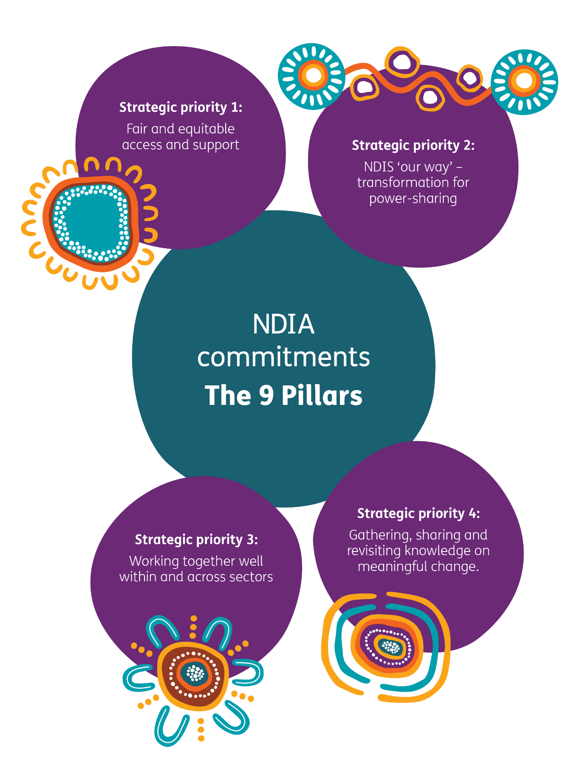


Strategic priority 1: Fair and equitable access and support
Focus area 1.1 | Focus area 1.2 | Focus area 1.3 | Focus area 1.4
Getting access – pathways into the NDIS | Getting support – pathways through the NDIS | Making choices – expanding support options | Feeling safe – culturally safe spaces and support
Objective:  To create fair and culturally safe pathways and more opportunities to access the NDIS for First Nations people with disability. | Objective:  To enhance and embed respect for the voices of all First Nations participants, their families, communities and advocates in deciding on their priorities and how they are met. | Objective:  To increase and expand existing and new disability services in areas with culturally thin markets for First Nations people with disability. | Objective:  To embed cultural safety in disability services for First Nations people with disability throughout their NDIS journey.

We know this is happening if:
First Nations people with disability, together with their families, communities and advocates, have fair and equitable pathways into the NDIS in all geographic locations, including on Country. First Nations people with disability can lead their priorities and planning in a holistic and self-determined way and have their unique needs met through culturally safe support, spaces and services.

Why is this important?
The NDIS is an important opportunity for First Nations people with disability to have a higher quality of life through access to culturally safe services that reflect their priorities and meet their cultural and individual needs in a fair and equitable way.
While First Nations people with disability are accessing the NDIS, the actual need for disability services among First Nations communities is far greater than the number of First Nations people in the NDIS. This has been highlighted in recent national reviews and inquiries that were informed by the knowledge and experience of First Nations people involved in the disability sector.
It is possible to address these unmet needs if the multiple barriers that First Nations people with disability face in their NDIS journey are proactively addressed. This begins with pathways into the NDIS, where the costs of getting to and paying for required medical and allied health assessments is often prohibitive. The application process can also be complex, time-consuming and intimidating, and involve unfamiliar language.
Once First Nations people become NDIS participants, there are further barriers to be overcome, including:
- the NDIS pathway, including needs assessments and budget setting, is done by people far removed from the local and cultural context, who have limited understanding of cultural safety and are unfamiliar with the supports and services available in each community
- lack of reliability and accountability of the NDIA in its communications with NDIS participants
- First Nations people needing to recount their stories multiple times across various contexts, leading to fatigue and a sense of being unheard
- NDIS planning processes must include First Nations people with disability, their families, communities and advocates as expert knowledge holders. Planning must recognise cultural forms of care and healing as sources of strength, care and support, including family and connection to Country.
Other barriers to overcome are:
- the limited number and range of services that are accessible for First Nations participants in their local area
- available services having limited understanding of and relationships with First Nations people, combined with limited knowledge and understanding of cultural safety, resulting in a lack of culturally safe spaces, supports and services.

Focus areas, objectives and signs of success

Focus area 1.1: Getting access – pathways into the NDIS
Objective: To create fair and culturally safe pathways and more opportunities to access the NDIS for First Nations people with disability.
Signs of success
We know this is successful if:
- First Nations people with disability have equitable access to the NDIS – equal to the rate of disability across First Nations communities.
- First Nations people with disability have a greater number of culturally safe entry points for accessing and applying to the NDIS. These entry points are combined with financial, personal, peer and resources support during the process, regardless of their geographical location.
- First Nations people with disability are empowered, well informed about their options, and feel culturally safe and respected during the NDIS application process.
- First Nations people with disability are well supported by people of their choice during the NDIS application process.
- More First Nations people are employed at the entry point for pathways into the NDIS.

Focus area 1.2: Getting support – pathways through the NDIS
Objective: To enhance and embed respect for the voices of all First Nations participants, their families, communities and advocates in deciding on their priorities and how they are met.
Signs of success
We know this is successful if:
- First Nations participants, their families, communities and advocates are centrally involved in making decisions about their needs and priorities during planning.
- First Nations participants, their families, communities and advocates are well informed about their options and feel culturally safe and respected on their pathway through the NDIS.
- First Nations participants experience consistency, predictability and transparency from their services and supports, and feel safe and secure on their pathway through the NDIS.

Focus area 1.3: Making choices – expanding support options
Objective: To increase and expand existing and new disability services in areas with culturally thin markets for First Nations people with disability.
Signs of success:
We know this is successful if:
- The NDIA First Nations Market and Sector Development Strategy creates more First Nations disability service providers who are distributed equitably on a geographical basis. They include Aboriginal community-controlled disability services, community-based cooperatives and First Nations businesses.
- Overall, there are more providers delivering, or with realistic capacity to deliver, culturally safe services to First Nations participants that meet their unique needs, who are distributed equitably on a geographical basis.
- First Nations participants can make meaningful choices in their planning pathway to meet their priorities and fully utilise their budget to meet their distinct cultural and individual needs.
- The NDIS Alternative Commissioning initiative is in place as standard practice, is available across all geographical locations and establishes local relationships with First Nations people so priorities for First Nations people with disability are addressed.
- A range of NDIA First Nations initiatives for addressing specific disability needs are in place as standard practice and available across all geographical locations.

Focus area 1.4: Feeling safe – culturally safe spaces and support
Objective: To embed cultural safety in disability services for First Nations people with disability throughout their NDIS journey.
Signs of success
We know this is successful if:
- First Nations participants, their families, communities and advocates, feel culturally safe and respected by disability services and their staff.
- All disability services undertake localised and holistic cultural training, as well as cultural safety training that includes a disability focus.
- First Nations participants can access a supported pathway for making enquiries or submitting complaints to the NDIS Quality and Safeguards Commission. Complaints are easy and safe to make, and support is appropriate to participant’s needs. Complaints receive a prompt response, are taken seriously and treated with discretion in accordance with the participant’s wishes.

Strategic priority 2: NDIS ‘our way’ – transformation for power-sharing
Focus area 2.1 | Focus area 2.2 | Focus area 2.3
‘Talkin up loud’ – First Nations governance and co-design of policies, programs and quality standards | Aboriginal community-controlled disability services | Care ‘our way’ – community and family-focused services and support
Objective:  To ensure the agency of First Nations people is recognised as fundamental for exercising and embedding self-determination in the governance of the NDIA and the co-design of policies, services and supports, and quality standards. | Objective:  To establish genuine partnerships that privilege Aboriginal community-controlled services for design and delivery of adequately funded and sustainable culturally safe disability programs and services that meet the distinct cultural and individual needs of First Nations people. | Objective:  A: To expand and embed adequately funded and sustainable community and family-focused services and support that meet the distinct cultural and individual needs of First Nations people with disability.  B: To ensure self-determination and agency of First Nations people is centred as standard practice when developing, embedding and evaluating community and family-focused services and support.

We know this is happening if:
First Nations people with disability, together with their families, communities and advocates, are actively involved in shaping and making the decisions about how policies, programs and practices ensure that First Nations people with disability experience holistic, culturally safe and effective care at all levels of the NDIS.

Why is this important?
First Nations people have sound historical and contemporary reasons for having low trust and being cautious about whether the risk of engaging with the NDIS outweighs the rewards. Historically, government initiatives have been grounded in racism and have exercised power and control over First Nations people, causing harm and trauma. This has contributed to the higher level of disability among First Nations people relative to the rest of the Australian population, and a lower level of access to disability services.
In the contemporary context, true power-sharing between government and First Nations people remains rare and racism continues, as highlighted in recent national reviews and inquiries. Governments require significant transformation of how they do business so that First Nations people can do things ‘our way’: where collective approaches, cultural knowledge and protocols are valued, cultural safety is a priority, and cultural and spiritual wellbeing are centred.
The NDIA can demonstrate its commitment to power-sharing and improve its reputation by respecting the self-determination and agency of First Nations people in the governance of the NDIA and the co-design of policies, services and supports. This includes revisiting what quality means for First Nations NDIS participants, their families, communities and advocates, and reflecting this in the quality standards and safeguards that disability services must meet.
Aboriginal community-controlled services have a reputation for delivering holistic and culturally safe services to First Nations communities. Resourcing them at a higher level to provide more service options for First Nations people with disability is a wise approach. This must be combined with lifting the commitment and ability of mainstream disability services to provide culturally safe services, because there are locations where Aboriginal community-controlled services do not operate, and because many First Nations people with disability use mainstream services.
The services and types of support available to First Nations participants is another essential area for transformation. They need to be community and family focused, and designed by First Nations people.

Focus areas, objectives and signs of success

Focus area 2.1: ‘Talkin’ up loud’ – First Nations governance and co-design of policies, programs and quality standards
Objective: To ensure the agency of First Nations people is recognised as fundamental for exercising and embedding self-determination in the governance of the NDIA and the co-design of policies, services and supports, and quality standards.
Signs of success
We know this is successful if:
- There is First Nations representation on all NDIA and NDIS governance bodies, and advisory, reference and working groups.
- It is standard practice, at both NDIA and community levels, for First Nations people to co-design all policies and programs intended for or impacting on First Nations participants.
- The NDIS Practice Standards are updated by First Nations people to reflect cultural safety and best practice in working with First Nations people. All groups in the NDIA engage regularly with and take leadership from the First Nations Group on matters concerning First Nations people.

Focus area 2.2: Aboriginal community-controlled disability services
Objective: To establish genuine partnerships that privilege Aboriginal community-controlled services for design and delivery of adequately funded and sustainable culturally safe disability programs and services that meet the distinct cultural and individual needs of First Nations people.
Signs of success
We know this is successful if:
- In consultation with the NDIA First Nations Group, Aboriginal community-controlled services are approached first to design and deliver expanded or new disability services and supports for First Nations people with disability.
- Sustainable, adequately funded, culturally safe and effective Aboriginal community-controlled disability programs and services are delivered for First Nations people with disability and their families and communities across all geographical locations.
- The NDIA maintains effective and mutually beneficial partnerships with Aboriginal community-controlled disability services.

Focus area 2.3: Care ‘our way’ – community and family-focused services and support
Objective A: To expand and embed adequately funded and sustainable community and family-focused services and support that meet the distinct cultural and individual needs of First Nations people with disability.
Objective B: To ensure self-determination and agency of First Nations people is centred as standard practice when developing, embedding and evaluating community and family-focused services and support.
Signs of success
We know this is successful if:
- Sustainable and adequately funded community and family-focused services and support operate across all geographical locations for First Nations participants.
- First Nations participants, their families and communities, experience culturally safe and meaningful outcomes from community and family-focused services and support.
- At both NDIA and community levels, First Nations people co-design all policies, services and supports intended for or impacting on First Nations participants.

Strategic priority 3: Working together well within and across sectors
Focus area 3.1 | Focus area 3.2 | Focus area 3.3 | Focus area 3.4
Accountability for cultural safety in all services | Integrated and flexible services through regional partnerships | Sustainable delivery of disability services | Strong collaboration across systems and sectors
Objective:  To establish and embed accountability mechanisms for ensuring cultural safety is present across the NDIS. | Objective:  To raise expectations of regional partnerships for ensuring the provision of integrated and flexible services for First Nations people with disability. | Objective:  To grow the capability and capacity of regional and remote services for sustainable delivery of disability services to First Nations people with disability. | Objective:  To strengthen the alignment of national policy commitments and the level of collaboration across government for improving support for First Nations people with disability.

We know this is happening if:
At national, regional and local levels there is sustained commitment to effective and accountable collaboration between all services, systems and sectors with which First Nations people with disability interact. This ensures that support flows well in a culturally safe and integrated way for First Nations people with disability throughout their NDIS journey.

Why is this important?
First Nations people with disability, along with their families, communities and advocates, must be directly involved in the governance, co-design and delivery of the NDIS. This is vital for achieving fair and equitable outcomes for First Nations NDIS participants and must be supported by everyone involved in the NDIS.
‘Everyone involved’ includes a wide range of people, groups, organisations and sectors who need to work together collaboratively and flexibly in a culturally safe way. It ranges from large national, state or territory organisations, to regionally focused organisations and small, local community-based services. It includes different sectors, such as health, education, early childhood, housing, justice, employment and aged care, as well as other specialist support services. How effectively everyone works together influences the NDIS experience for First Nations people with disability – both positively and negatively.
Currently, First Nations people with disability, their families, communities and advocates, are not experiencing the level of effective and accountable collaboration that is needed to create fair and equitable outcomes.
The NDIA can take a proactive role, so that collectively, everyone involved in the NDIS plays their role to achieve better outcomes. The NDIA can:
- Model and set benchmarks for good and culturally safe practice when working with First Nations people with disability, their families, communities and advocates, and monitor how well these benchmarks are met.
- Be a ‘conductor’, by facilitating partnerships that bridge relationships between service providers, local communities and different government sectors.
- Provide direct support and facilitate collaboration to grow more sustainable services in all geographical areas with culturally thin markets.
- Be a leader and a cooperative and active contributor to national action focused on better outcomes for First Nations people, especially First Nations people with disability.

Focus areas, objectives and signs of success

Focus area 3.1: Accountability for cultural safety in all services
Objective: To establish and embed accountability mechanisms for ensuring cultural safety is present across the NDIS.
Signs of success
We know this is successful if:
- The NDIA requires cultural safety training to be mandatory for NDIA staff, NDIS Quality and Safeguards Commission auditors, NDIS partners in the community and registered provider staff.
- All registered providers meet the cultural safety elements of the updated NDIS Practice Standards when audited by the NDIS Quality and Safeguards Commission.
- The NDIA provides targeted encouragement and support for unregistered providers to develop their understanding and skills in cultural safety.
- When independently assessed, the NDIA meets the ‘developed’, ‘advanced’ or equivalent level for all elements of an approved organisational cultural safety audit tool(s).

Focus area 3.2: Integrated and flexible services through regional partnerships
Objective: To raise expectations of regional partnerships for ensuring the provision of integrated and flexible services for First Nations people with disability.
Signs of success
We know this is successful if:
- Regional partnerships with First Nations governance structures operate in all geographical locations and are supported by the NDIA to undertake and sustain collaborative planning and review cycles on the provision of integrated and flexible services for First Nations people with disability.
- The NDIA implements systems that monitor and support the effectiveness of collaborative planning and review cycles by regional partnerships for the provision of integrated and flexible services.
- There are high levels of collaboration between regional partnership members in the provision of integrated and flexible services for First Nations people with disability.
- First Nations participants, their families, communities and advocates, receive integrated and flexible services from their service providers.

Focus area 3.3: Sustainable delivery of disability services
Objective: To grow the capability and capacity of regional and remote services for sustainable delivery of disability services to First Nations people with disability.
Signs of success
We know this is successful if:
- The NDIA creates or supports more place-based First Nations disability service providers in regional, remote and very remote areas, providing sustainable support for First Nations people with disability. They include Aboriginal community-controlled disability services, community-based cooperatives and other First Nations businesses.
- First Nations people in regional, remote and very remote areas can access and participate in training pathways into the disability workforce.
- First Nations people in regional, remote and very remote areas represent a growing proportion of the disability workforce.

Focus area 3.4: Strong collaboration across systems and sectors
Objective: To strengthen the alignment of national policy commitments and the level of collaboration across government for improving support for First Nations people with disability.
Signs of success
We know this is successful if:
- Alignment between national policy commitments and accountability mechanisms is clearly articulated and available in both plain language and accessible versions.
- The NDIA is a leader in collaborative action across government that results in improved support for First Nations people with disability.
- The NDIA is an active and effective contributor to achieving Closing the Gap priority reforms and socioeconomic targets for First Nations people with disability, their families, communities and advocates.

Strategic priority 4: Gathering, sharing and revisiting knowledge about meaningful change
Focus area 4.1 | Focus area 4.2 | Focus area 4.3 | Focus area 4.4
Indigenous data sovereignty and governance | Truth telling – are we making a difference? | Translating our learnings into meaningful action | Sharing and integrating relevant data sets
Objective:  To enhance NDIA and NDIS capability in Indigenous data sovereignty and governance principles for gathering and sharing data with and about First Nations participants. | Objective:  To embed monitoring and evaluation activity that tracks if First Nations participants have sufficient, meaningful, consistent and culturally safe NDIS services and supports and good outcomes. | Objective:  To improve the translation of monitoring and evaluation learnings about the knowledge, experience and aspirations of First Nations participants, their families, communities and advocates, into meaningful action. | Objective:  To improve the quality and integration of data about First Nations people with disability from different data sources, using a strength-based approach.

We know this is happening if:
Monitoring, evaluation and data sharing activities are co-designed with First Nations people with disability, their families, communities and advocates. The knowledge gathered reflects their experiences of both what is changing in a meaningful and acceptable way, and what is not changing. This collective story is shared and revisited with First Nations participants, their families, communities and advocates. The learnings are consistently translated into action, so good practice expands across the NDIS and areas of concern are proactively addressed.

Why is this important?
This First Nations Strategy outlines intentions for change that can improve experiences and outcomes for First Nations participants, their families and communities. However, it will be important to link these intentions with practical actions in the strategy implementation plan. Accountability is required to determine if, and how quickly, these intentions become reality, and what action is taken where progress is lagging or concerns are identified. When culturally safe and effective practice is identified, it needs to be shared and applied broadly across the NDIS.
Tracking progress and achievements against the First Nations Strategy requires the NDIA to refine and expand its current monitoring, evaluation and knowledge translation activities. The NDIA must establish frameworks for how it manages and represents information on First Nations people with disability. This will require several shifts, including:
- Establishing a more targeted approach to data that deeply considers and respects Indigenous data sovereignty and governance principles.
- Focusing on what First Nations participants, their families, communities and advocates define as sufficient, meaningful, consistent and culturally safe supports and outcomes, which can better describe the ‘reasonable and necessary supports’ in the National Disability Insurance Scheme Amendment (Getting the NDIS Back on Track No.1) Act 2024.
- Establishing a First Nations-specific monitoring and evaluation framework, with a set of indicators to assess the performance of the NDIS.
- Acting on learnings promptly, so that effective programs or models of support for First Nations people with disability become standard practice and new programs and models of support learn from what has previously worked and what has not.
- When accessing and integrating data on First Nations people with disability from multiple data sets, moving beyond ‘big data’ and creating local-level data pictures that are easily shared with communities. These can be considered alongside local monitoring and evaluation outcomes to learn about and respond to what is happening on the ground, while maintaining the privacy, dignity and confidentiality of First Nations people with disability.

Focus areas, objectives and signs of success

Focus area 4.1: Indigenous data sovereignty and governance
Objective: To enhance NDIA and NDIS capability in Indigenous data sovereignty and governance principles for gathering and sharing data with and about First Nations participants.
Signs of success
We know this is successful if:
- The NDIA implements an Indigenous data sovereignty and governance framework that is co-designed with First Nations people.
- Indigenous data sovereignty and governance principles are enacted on a consistent basis by the NDIA, as assessed by First Nations people.
- First Nations data gathered and shared by the NDIA is useable and helpful in making decisions at national, regional and local levels.

Focus area 4.2: Truth telling – are we making a difference?
Objective: To embed monitoring and evaluation activity that tracks if First Nations participants have sufficient meaningful, consistent and culturally safe NDIS services and supports and good outcomes.
Signs of success
We know this is successful if:
- The NDIA implements a First Nations monitoring and evaluation framework that is co-designed with First Nations people.
- Monitoring and evaluation are built into the funding model for disability programs and services for First Nations participants, their families and communities, as standard practice.
- Monitoring and evaluation activity provides a clear and accountable picture of NDIS performance that is reported back to and truthfully reflects the knowledge and aspirations shared, and the outcomes experienced by, First Nations participants, their families, communities and advocates.

Focus area 4.3: Translating our learnings into meaningful action
Objective: To improve the translation of monitoring and evaluation learnings about the knowledge, experience and aspirations of First Nations participants, their families, communities and advocates, into meaningful action.
Signs of success
We know this is successful if:
- Areas of concern within NDIS policies and services are proactively addressed based on monitoring and evaluation learnings in partnership with First Nations people.
- Monitoring and evaluation learnings about areas of concern within NDIS policies and services are proactively addressed in partnership with First Nations people.
- Previously demonstrated effective and culturally safe practice informs the co-design of all new policies and services for First Nations people with disability.

Focus area 4.4: Sharing and integrating relevant data sets
Objective: To improve the quality and integration of data about First Nations people with disability from different data sources using a strengths-based approach.
Signs of success
We know this is successful if:
- Integrated data sets represent both the strengths of, and challenges faced by, First Nations people with disability across different aspects of life.
- Local-level data pictures are created from integrated data sets to provide insight into different support needs and service options at regional and local levels.
- First Nations people with disability, their families and communities, see their situations and experiences represented in integrated data sets.

Ruth advocates for disability equity
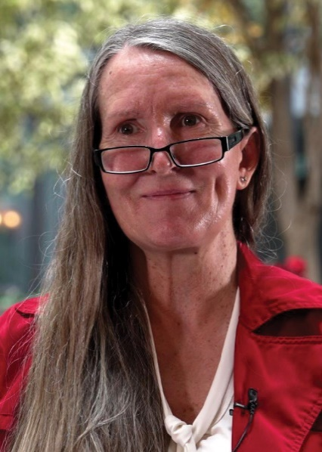
As a member of the NDIS First Nations Strategy Working Group, I have felt heard. I joined the working group to make sure that First Nations people with disability get the services they need, on an equitable basis and regardless of where they live.
I’m grateful for the NDIS supports that I get in Naarm (Melbourne). Having access to a First Nations support worker has changed my life. Besides helping me live with an acquired brain injury, my support worker has helped me to connect with my Aboriginal heritage. I’ve found out that my great-grandfather from Tasmania was taken from his mother at 4 years old and placed in an orphanage.
Many First Nations people with disability have slipped through the cracks, especially those living in regional and remote areas. They should be able to get the same help I do living in the city. I’m part of the working group to make sure everybody gets the help they need and deserve. I’m hopeful that the work we’re doing means we’ll get happier, healthier people.
Ruth Whybrow
Naarm

Appendix

Glossary
Aboriginal Community Controlled Organisation (ACCO) is defined in Clause 44 of the National Agreement on Closing the Gap as a form of self-determination. Aboriginal and/or Torres Strait Islander Community-Controlled Organisations deliver services, including land and resource management, that build the strength and empowerment of Aboriginal and Torres Strait Islander communities and people. ACCOs are generally incorporated under relevant legislation, not-for-profit, controlled and operated by Aboriginal and/or Torres Strait Islander people, and connected to the community or communities in which they deliver services. ACCOs are also usually governed by a majority Aboriginal and/or Torres Strait Islander body.
Advocate is a person who represents another person’s interests.
Agency refers to an individual’s and community’s capability or ability to act according to their collective and personal priorities and needs.
Big data refers to the large volumes of diverse and complex data that can be used to inform decision-making, improve services, and address the needs of First Nations communities.
Co-design describes empowering, reciprocal, and inclusive processes that honour the knowledge, perspectives, and priorities of First Nations people and communities and work towards ending colonially driven inequity through capacity building, cultural respect and social responsibility.
Collaboration is working together to identify and act on shared priorities in a transparent and respectful way.
Community refers to informal social and family groups that have a shared sense of belonging and identity and support social and emotional wellbeing.
Country describes the lands, waterways and seas to which First Nations people are connected. The term encompasses complex ideas about law, place, custom, language, spiritual belief, cultural practice, material sustenance, family and identity.
On Country encompasses the need for services to be grounded and located in places where First Nations people and their families have cultural connections.
Closing the Gap reporting is a part of the National Agreement on Closing the Gap. The state, territory and Commonwealth governments are each committed to developing their own Closing the Gap Implementation Plan and reporting every year on their actions to achieve the outcomes of the agreement.
Cultural safety A culturally safe environment is created when First Nations people define and decide what is culturally safe for them, and report that:
- their experiences are believed and validated
- their cultures are centred and valued in policy development, research, evaluation, and service design and delivery
- they feel welcomed and respected in policy, research, evaluation and service environments
- they see other Aboriginal and Torres Strait Islander people working in the policy, research, evaluation or service context
- they do not experience any form of racism in policy, research, evaluation and service contexts or processes.
Culturally thin markets describe not only a gap in available disability services and support, but also a lack of First Nations-led services and a lack of culturally safe services. Thin markets occur where there is a lack of services available. Economically thin markets occur when providers are either absent or they do not have the capacity to meet the demand for services required in a specific area.
A data set or data picture is an organised collection of data. It is generally associated with a unique body of work and covers one topic at a time.
Empowerment occurs when there is support for First Nations ownership and true partnership with government, and recognition of the diversity of cultures and circumstances of First Nations people.
Engagement with First Nations communities should have First Nations people at the centre and be guided by the principles of the UNDRIP and the UNCRPD. Engagement needs to be trauma-informed and culturally appropriate. First Nations people should feel culturally safe and have choice about how to engage. Engagement should be purposeful, respectful and facilitate clear avenues for communication with First Nations people with disability, their carers and families.
Equity is giving people what they need based on their starting point, so they can be successful. People may need different things to achieve equal outcomes.
Fair is something that is reasonable, right and just.
First Nations people is respectfully used throughout this document to be inclusive of the diverse Aboriginal peoples and Torres Strait Islander nations across Australia, and their unique ‘Country’, Kinship and Ways of Knowing, Being and Doing.
First Nations participant refers to a person who meets the NDIS access requirements and who self-identifies as a First Nations person.
First Nations people with disability refers to Aboriginal and Torres Strait Islander people who have a disability and who may or may not be formally recognised or supported by the NDIS.
Flexible refers to allowing for adjustments and modifications to a participant’s NDIS pathway, including needs assessments and budget settings, to cater for evolving circumstances.
Holistic refers to the whole person (physical, cultural, social, emotional and spiritual) as interconnected with Country, family and community.
Indigenous data is information, in any format, that is about Indigenous peoples, knowledge systems, customs, resources or territories, or that impacts Indigenous lives at the collective and/or individual level.
Indigenous data sovereignty is the right of Indigenous peoples to own, control, access and possess data that derive from them, and which pertain to their members, knowledge systems, customs, resources or territories.
Indigenous data governance is the right of Indigenous peoples to autonomously decide what, how and why Indigenous data are collected, accessed and used. It ensures that data on or about Indigenous peoples reflects [their] priorities, values, cultures, worldviews and diversity.
Intersectionality or intersecting refers to how different aspects of a person’s identity can expose them to overlapping forms of discrimination and marginalisation. Intersectoral (collaboration) refers to the social and economic factors influencing the health of a population within and between sectors at the local, regional, national and global levels. The expression ‘intersectionality’ is usually used to describe the multi-layered forms of discrimination and disadvantage that people with disability may experience, including First Nations people, people from culturally and linguistically diverse communities, women and girls, and lesbian, gay, bisexual, trans and gender diverse, intersex, queer, asexual and sistergirl and brotherboy (LGBTIQASB+) people with disability.
The National Disability Insurance Agency (NDIA) is an independent statutory agency. As part of its role, it implements the National Disability Insurance Scheme.
The National Disability Insurance Scheme (NDIS) funds necessary support and care for children and adults living with a disability or permanent cognitive impairment.
LGBTIQASB+ lesbian, gay, bisexual, transgender, intersex, queer, asexual, sistergirl, brotherboy plus. Sistergirl and brotherboy are culturally distinct queer identities in First Nations communities in Australia. Sistergirl and brotherboy are used as terms of endearment throughout First Nations communities.
Navigators help individuals and their families navigate the NDIS and understand, find and use mainstream and community services as well as foundational supports.
Partnership focuses on equal participation in decision-making, implementation, and ongoing monitoring to accelerate improvements in various life outcomes for Aboriginal and Torres Strait Islander peoples. It includes shared decision-making between governments and Aboriginal and Torres Strait Islander representatives and means that both parties work together to develop and implement policies and strategies.
Peer sharing is the practice of telling stories and sharing knowledge between people who have a shared identity or shared experience.
Planning pathway refers to each NDIS participant receiving tailored support that respects their unique needs and identities. It includes a personalised plan that considers the person’s specific goals, preferences and circumstances.
Power-sharing is when individuals share their experiences and listen to others to gain a better understanding of each other, and build relationships and offer support.
Relationship is the action or approach of connection and engagement between people.
Respect is the core value, an interrelationship that recognises the freedom of choice, inherent worth and essential equality of a person.
Self-determination describes the rights of First Nations people to set priorities, make decisions and pursue self-development on their own terms as laid out in the United Nations Declaration on the Rights of Indigenous Peoples.

National Disability Insurance Agency
ndis.gov.au
Telephone 1800 800 110
Webchat ndis.gov.au
Follow us on our social channels
Facebook, Twitter, Instagram, YouTube, LinkedIn
For people who need help with English
TIS: 131 450
For people who are deaf or hard of hearing
TTY: 1800 555 677
Voice relay: 1800 555 727
National Relay Service: relayservice.gov.au

Australian Bureau of Statistics, Australia: Aboriginal and Torres Strait Islander population summary, 2021, accessed 4 December 2024.
NDIS (National Disability Insurance Scheme), Participant Data [data set], https://dataresearch.ndis.gov.au, 2024, accessed 23 November 2024.
First Peoples Disability Network, Submission 95 - Closing the Gap Review, 2023, accessed 4 December 2024.
S Avery, Culture is Inclusion: A Narrative of Aboriginal and Torres Strait Islander People with Disability, Western Sydney University, 2018.
First Peoples Disability Network, Intersectional Dimensions on the Right to Health for Indigenous Peoples – A Disability Perspective, n.d. Prepared for the Expert Mechanism on the Rights of Indigenous Peoples (EMRIP) study on ‘The Right to Health for Indigenous Peoples’.
UN General Assembly, United Nations Declaration on the Rights of Indigenous People, A/RES/61/295, 13 September 2007, accessed 3 December 2024; UN General Assembly, Convention on the Rights of Persons with Disabilities, A/RES/61/106, Annex I, 13 December 2006, accessed 3 December 2024.
Department of Social Services (DSS), Australia’s Disability Strategy 2021-2031, DSS, Australian Government, 2021, accessed 23 November 2024.
Australian Government, National Agreement on Closing the Gap, Australian Government, 2020, accessed 23 November 2024.
Australian Government, Disability Sector Strengthening Plan, Australian Government, 2022, accessed 23 November 2024.
D Rigney, S Bignall, A Vivian and S Hemming, Indigenous nation building and the political determinants of health and wellbeing: Discussion paper, Lowitja Institute, Melbourne, 2022, p 9, accessed 17 December 2024.
J Mohamed, K Stacey, H Watson and T Smith, Allyship and cultural safety training program, Lowitja Institute, Melbourne, 2021.
See also National Disability Insurance Scheme (Getting the NDIS Back on Track No. 1) (NDIS Supports) Transitional Rules 2024.
J Mohamed, K Stacey, H Watson and T Smith, Allyship and cultural safety training program, Lowitja Institute, Melbourne, 2021, p 6.
Royal Commission into Violence, Abuse, Neglect and Exploitation of People with Disability, First Nations Engagement Principles, 2020
Yoorrook Justice Commission, Indigenous data sovereignty and data governance: Information Sheet 4, Yoorrook Justice Commission, Melbourne, 2022, p 1,and T Kukutai and J Taylor, ‘Data sovereignty for indigenous peoples: current practice and future needs’’ in T Kukutai and J Taylor (eds), Indigenous Data Sovereignty: Toward an Agenda , ANU Press, 2016.
Kukutai & Taylor 2016 and Snipp 2016, cited in Yoorrook Justice Commission, 2022, p 1.
Maiam nayri Wingara Indigenous Data Sovereignty Collective, Defining Indigenous Data Sovereignty and Indigenous Data Governance, Maiam nayri Wingara Indigenous Data Sovereignty Collective website, 2018, accessed 17 December 2024.
Royal Commission into Violence, Abuse, Neglect and Exploitation of People with Disability, Final Report – Volume 2, About the Royal Commission, 2023. See also K Soldatic, C Sullivan, L Briskman, J Leha, W Trewlynn and K Spurway, ‘Social Inclusion and Exclusion for First Nations LGBTIQ+ People in Australia’, Social Inclusion, 2021, 9:1–6, doi:10.17645/si.v9i2.4280.
Article 3 of UNDRIP recognises Indigenous peoples’ right to self-determination, which includes the right ‘to freely determine their political status and freely pursue their economic, social and cultural development.’

